<html lang="en">

<head>

    <title>Document guvi</title>

</head>

<body>

    <div>

        <p>Lorem ipsum dolor sit amet consectetur adipisicing elit</p>

    </div>

    <p>Guvi Geek Network</p>

    </div>

    </div>

</body>

</html>

Output:



2.Contact us Form

<html lang="en">

<head>

    <meta charset="UTF-8">

    <meta http-equiv="X-UA-Compatible" content="IE=edge">

    <meta name="viewport" content="width=device-width, initial-scale=1.0">

    <title>Contact us Form</title>

</head>

<body>

    <form>

        <label for="Name">Name</label><br>

        <input type="text" id="Name" placeholder="Your Name"><br>

        <label for="Mail id">Email Id</label><br>

        <input type="text" id="Mail id" placeholder="Your Mail id"><br>

        <label for="Message">Message</label><br>

        <input type="text" id="Message" placeholder="Your Message"><br>

        <input type="submit" value="submit">

    </form>

</body>

</html>

Output:

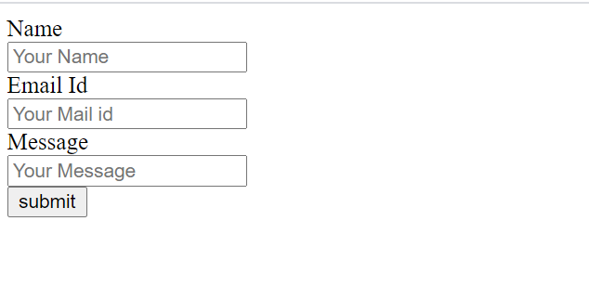

3.Use Certain HTML elements to Display in HTML page

<body>

    <ul>

        <li>Programming Language</li>

        <ul>

            <li>JavaScript</li>

        </ul>

        <ol>

            <ol type="a">

                <li>Angular</li>

                <li>React</li>

                <li>Vue</li>

            </ol>

        </ol>

        <ul>

            <li>Python</li>

        </ul>

        <ol>

            <ol type="a">

                <li>Django</li>

                <li>Flask</li>

            </ol>

        </ol>

        <ul>

            <li>Java</li>

        </ul>

        <ol>

            <ol type="a">

                <li>Spring</li>

                <li>Maven</li>

                <li>Hybernate</li>

            </ol>

        </ol>

    </ul>

    <ul>

        <li>Database</li>

    </ul>

    <ol>

        <ol type="a">

            <li>My SQL</li>

            <li>Mongo DB</li>

            <li>Cansandra</li>

        </ol>

</body>

</html>

Output:

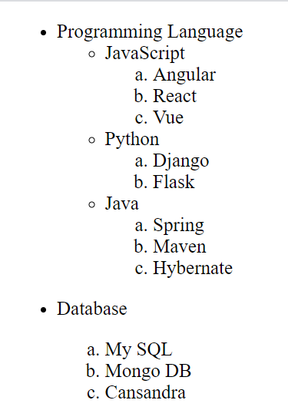

4. Anchor Tag in a New tab

<!DOCTYPE html>

<html lang="en">

<head>

    <meta charset="UTF-8">

    <meta http-equiv="X-UA-Compatible" content="IE=edge">

    <meta name="viewport" content="width=<a>, initial-scale=1.0">

    <title>Document</title>

</head>

<body>

    <a href="https://www.Google.com" target=_blank>Click here</a>

</body>

</html>

5. <body>

    <form>

        <label for="Name">Name</label><br>

        <input type="text" id="Name" placeholder="Your Name"><br>

        <label for="Mail id">Email Id</label><br>

        <input type="text" id="Mail id" placeholder="Your Mail id"><br>

        <label for="Address">Address</label><br>

        <input type="text" id="Address" placeholder="Your Address"><br>

        <label for="Phone number">Phone number</label><br>

        <input type="number" id="Phone number" placeholder="Your number"><br>

        <label for="salaried">Salaried</label><br>

        <input type="radio" id="salaried" name="Employee type"><br>

        <label for="Business">Business</label><br>

        <input type="radio" id="Business" name="Employee type"><br>

        <input type="submit" value="submit">

    </form>

</body>

Output:

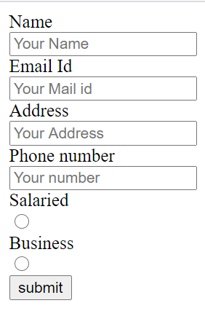

6.Create Form

<body>

    <h1>Yes! I Want to Subscribe to Mag-O-Zine</h1>

    <form>

        <label for="FirstName">First Name</label>

        <input type="text" id="FirstName">

        <label for="LasttName">Last Name</label>

        <input type="text" id="LasttName"><br>

        <label for="Address">Address</label><br>

        <input type="text" id="Address"><br>

        <label for="city">City</label><br>

        <input type="text" id="city">

        <label for="State">State</label>

        <input type="text" id="State">

        <label for="zip">ZIP</label>

        <input type="number" id="zip">

        <p>Subscribe to: <label class="container">

            <input type="checkbox">1 Year($19.95)

            <span class="checkmark"></span>

        </label>

            <label class="container">

        <input type="checkbox">2 Year($35.00)

        <span class="checkmark"></span>

        </label></p><br>

        <p>Send Me more Information about:</p><br>

        <label class="container">

            <input type="checkbox">Computer Fishing

            <span class="checkmark"></span>

        </label><br>

        <label class="container">

            <input type="checkbox">Fishing-Zine

            <span class="checkmark"></span>

        </label><br>

        <label class="container">

            <input type="checkbox">Cat-O-zine

            <span class="checkmark"></span>

        </label><br>

    </form>

</body>

</html>

Output:

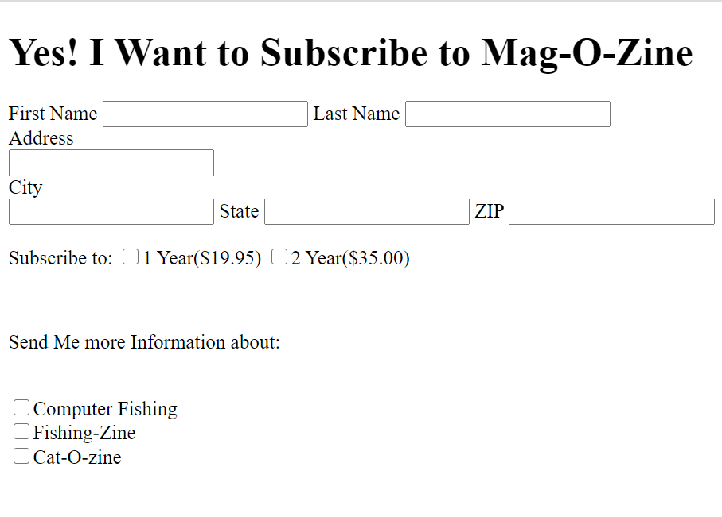

7.Create table

<body>

    <table>

        <thead>

            <tr>

                <th>State of health</th>

                <th colspan="2">Fasting value</th>

                <th colspan="1">After Eating</th>

                <tr>

                    <th></th>

                    <th>Minimum</th>

                    <th>Maximum</th>

                    <th>2 hours of Eating</th>

                </tr>

                <tbody>

                    <tr>

                        <td>Healty</td>

                        <td>70</td>

                        <td>100</td>

                        <td>Less than 10</td>

                    </tr>

                    <tr>

                        <td>Pre-Diabetes</td>

                        <td>101</td>

                        <td>126</td>

                        <td>140 to 200</td>

                    </tr>

                    <tr>

                        <td>Diabetes</td>

                        <td>126</td>

                        <td>N/A</td>

                        <td>More than 200</td>

                    </tr>

        </thead>

        </tbody>

    </table>

    </table>

</body>

</html>

Output:

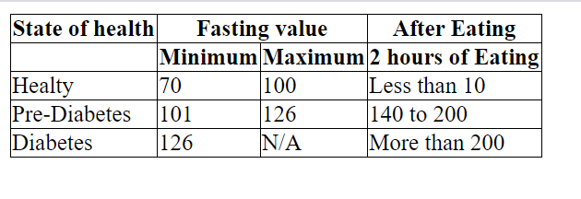

8.Input tag

<body>

    <form>

        <label for="name">Name</label><br>

        <input type="text" id="name" placeholder="Name"><br>

        <label for="password">Password</label><br>

        <input type="text" id="password" placeholder="password"><br>

        <input type="submit" value="submit">

        <input type="reset" value="reset">

    </form>

</body>

</html>

Output:

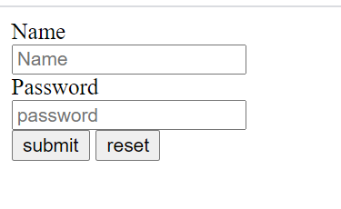

9.Highligth the Following text in HTML without using CSS

<!DOCTYPE html>

<html lang="en">

<head>

    <meta charset="UTF-8">

    <meta http-equiv="X-UA-Compatible" content="IE=edge">

    <meta name="viewport" content="width=device-width, initial-scale=1.0">

    <title>Document</title>

    <style>

        mark {

            background-color: grey;

            color: purple;

        }

    </style>

</head>

<body>

    <mark>HTML & CSS is awesome</mark>

</body>

</html>

Output:

